Home page data

|  |  |  |  |  |
| --- | --- | --- | --- | --- |
| url | method | parameter | value | note |
| /api/index/ | get |  |  | All posts home page |
|  |  |  |  |  |

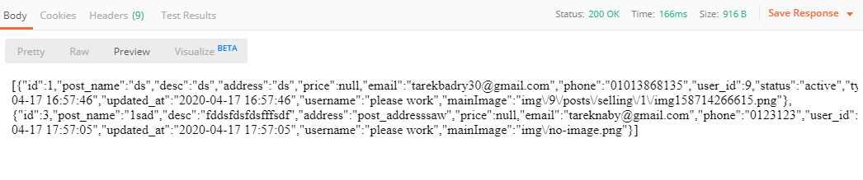

------------------------------------------------------------------------------------------------------------------------------------------

Post details

|  |  |  |  |  |
| --- | --- | --- | --- | --- |
| url | method | parameter | value | note |
| /api/postDetails/ | get | post_id | The id of post |  |
|  |  |  |  |  |

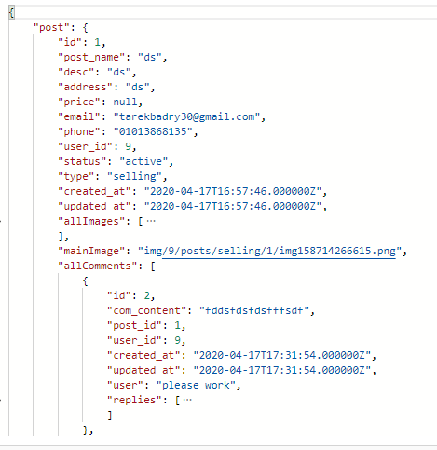

**Signup process**

==============[]-----with error input data---------- [] =====================

|  |  |  |  |  |
| --- | --- | --- | --- | --- |
| url | method | parameter | value | note |
| /api/register/ | post | name | Your name | Register new account |
|  |  | password | Your pass |  |
|  |  | email | Your email |  |

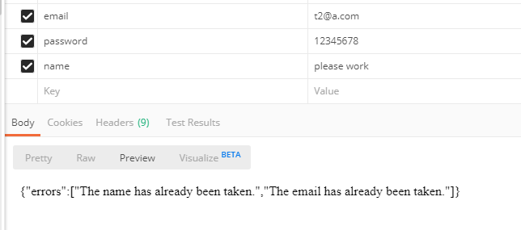

==============[]-----with correct input data---------- [] =====================

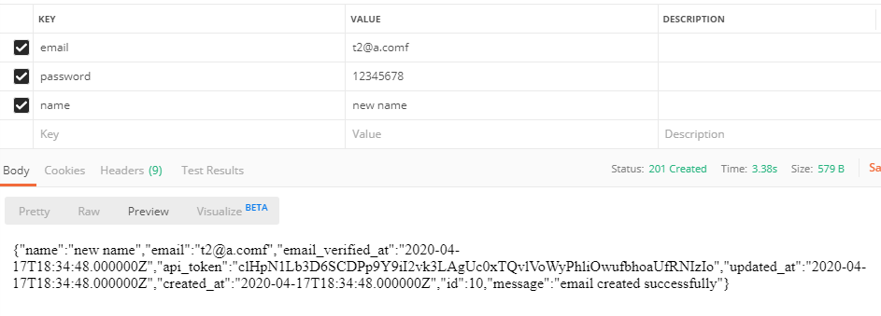

------------------------------------------------------------------------------------------------------------------------------------------

**Login process**

|  |  |  |  |  |
| --- | --- | --- | --- | --- |
| **url** | **method** | **parameter** | **value** | **note** |
| /lapi/ogin/ | post | password | Your pass | Register new account |
|  |  | email | Your email |  |
|  |  |  |  |  |

Api_token : random generate for each login process

Api_token : must passed as parameter for each connection between mobile app and server.

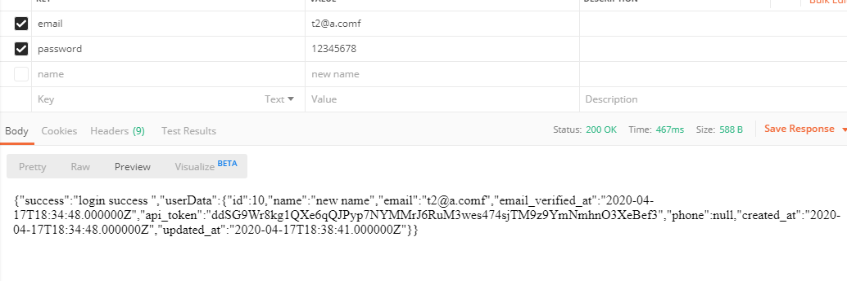

------------------------------------------------------------------------------------------------------------------------------------------

**My posts**

|  |  |  |  |  |
| --- | --- | --- | --- | --- |
| **url** | **method** | **parameter** | **value** | **note** |
| /api/myActiveRent/ | post | api_token | Your token |  |

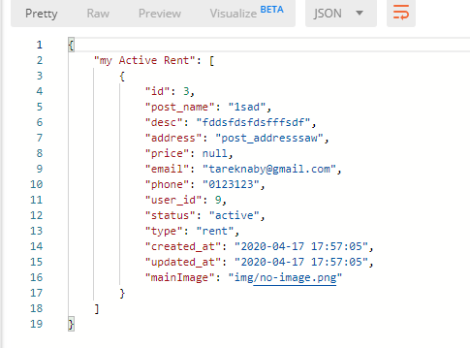

|  |  |  |  |  |
| --- | --- | --- | --- | --- |
| **url** | **method** | **parameter** | **value** | **note** |
| /api/myDisActiveRent/ | post | api_token | Your token |  |

|  |  |  |  |  |
| --- | --- | --- | --- | --- |
| **url** | **method** | **parameter** | **value** | **note** |
| /api/myActiveSell/ | post | api_token | Your token |  |

|  |  |  |  |  |
| --- | --- | --- | --- | --- |
| **url** | **method** | **parameter** | **value** | **note** |
| /api/myDisActiveSell/ | post | api_token | Your token |  |

------------------------------------------------------------------------------------------------------------------------------------------

**Insert new post**

|  |  |  |  |  |
| --- | --- | --- | --- | --- |
| **url** | **method** | **parameter** | **value** | **note** |
| /api/insertPost/ | post | api_token | Your token |  |
|  |  | post_name | Your new post title |  |
|  |  | post_desc | description |  |
|  |  | post_address | Address |  |
|  |  | type | rent | selling |  |
|  |  | mobile | 012102 |  |
|  |  | email | Email to connect |  |
|  |  | price | The price |  |

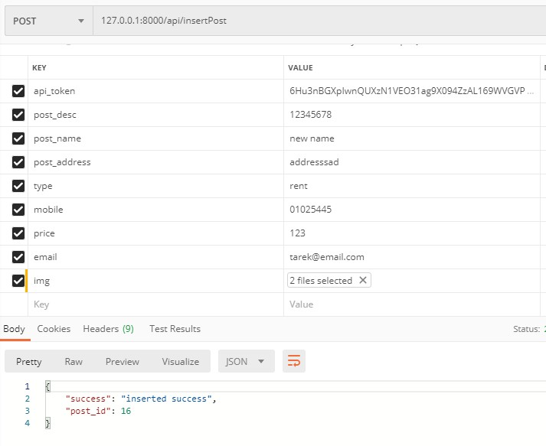

**Edit my post**

|  |  |  |  |  |
| --- | --- | --- | --- | --- |
| **url** | **method** | **parameter** | **value** | **note** |
| /api/editPost/ | post | api_token | Your token |  |
|  |  | post_id | Your post_id |  |

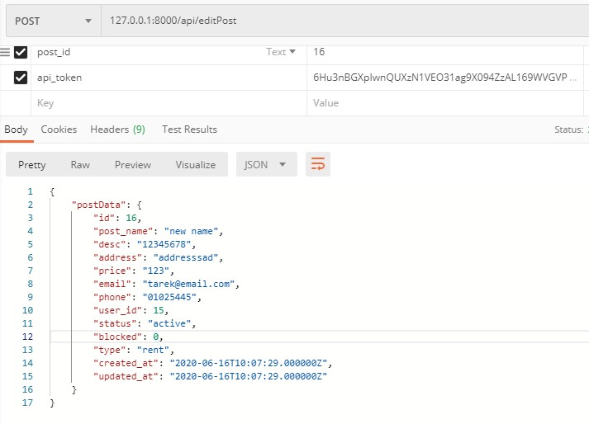

**update my post**

|  |  |  |  |  |
| --- | --- | --- | --- | --- |
| **url** | **method** | **parameter** | **value** | **note** |
| /api/updatePost/ | post | api_token | Your token |  |
|  |  | post_id | Your post_id |  |
|  |  | post_name | Your updated post title |  |
|  |  | post_desc | description |  |
|  |  | post_address | Address |  |
|  |  | type | rent | selling |  |
|  |  | mobile | 012102 |  |
|  |  | email | Email to connect |  |
|  |  |  |  |  |

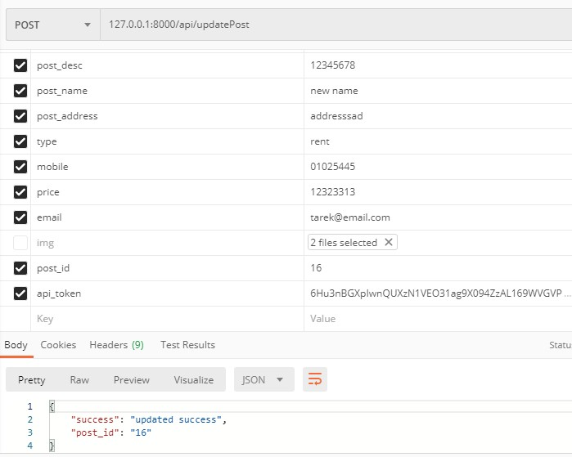

**delete my post**

|  |  |  |  |  |
| --- | --- | --- | --- | --- |
| **url** | **method** | **parameter** | **value** | **note** |
| /api/deletePost/ | post | api_token | Your token |  |
|  |  | post_id | Your post_id |  |

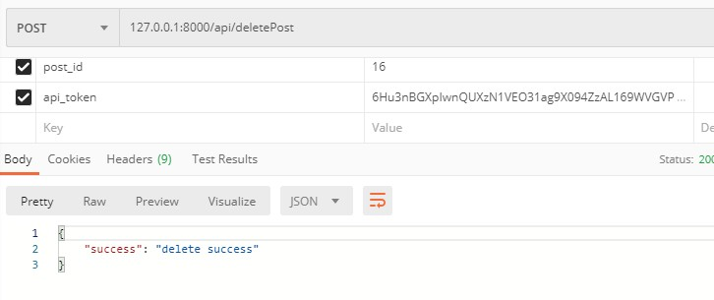

**Edit my profile**

|  |  |  |  |  |
| --- | --- | --- | --- | --- |
| **url** | **method** | **parameter** | **value** | **note** |
| /api/editProfile/ | post | api_token | Your token |  |

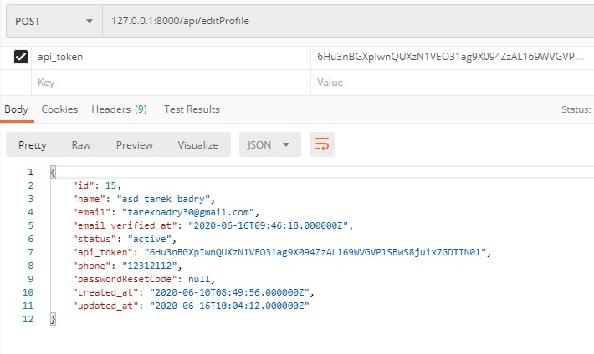

**Edit my profile**

|  |  |  |  |  |
| --- | --- | --- | --- | --- |
| **url** | **method** | **parameter** | **value** | **note** |
| /api/updateProfile/ | post | api_token | Your token | required |
|  |  | username |  | required |
|  |  | email |  | required |
|  |  | currentPass | Your current password | required |
|  |  | newPass |  | Optional |
|  |  | confirmedNewPass |  | Required if newPass set |

